Let your [clients/members/contacts] know about the BOOTCAMP!
This year’s Battle of the Buildings is a chance for organizations across the country to transform their buildings into lean, green, energy-saving machines in just 90 days—with the ENERGY STAR® National Building Competition: BOOTCAMP!
Encourage your [clients/members/contacts] who own or manage buildings to join the fun and team up with ENERGY STAR to engage employees and occupants, and build a workplace culture of energy conservation. It’s a great way to:
- Cut out energy and water waste, and save money on utility bills.
- Earn recognition from EPA and your community for environmental leadership.
- Engage employees and boost workplace pride.
- Deliver value to tenants in the form of a more efficient workplace.
- Achieve lasting benefits for your bottom line in just three months.
- Demonstrate the value of sustainability to decision makers.
- Use EPA-provided resources to save time and effort!

It doesn’t take long to make changes that reduce your energy bill for years to come. So use these materials to let others know about the opportunity to save energy, cut costs, and show environmental leadership. Encourage them to sign up today to compete!

Templates and Materials
Web Banners and Buttons 2
E-Postcard or Slide Image 3
Sample Newsletter Article 4
Sample Blast Email 5
Sample “Tweets” to Post on Twitter 6
Sample Web Text 7

Web Banners and Buttons
Post one of these web buttons or banners on your website, and link it to www.energystar.gov/BattleOfTheBuildings

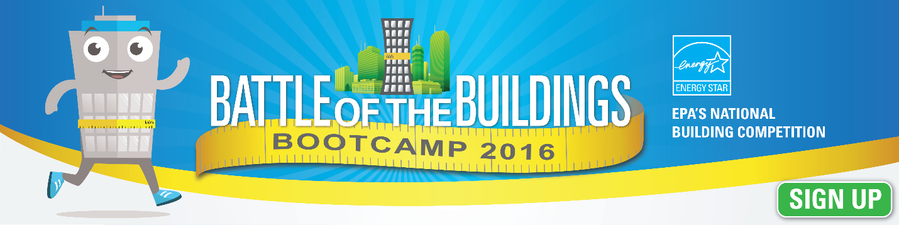
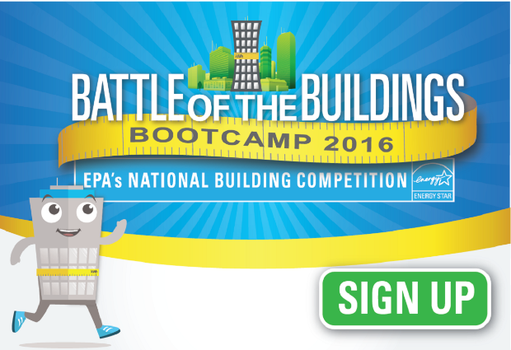
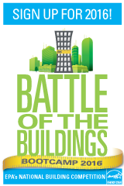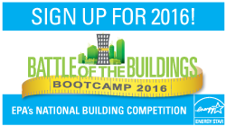

E-Postcard or Slide Images
Send either of these postcards via email, post them online, or put them in PowerPoint presentations. Link them to www.energystar.gov/BattleOfTheBuildings

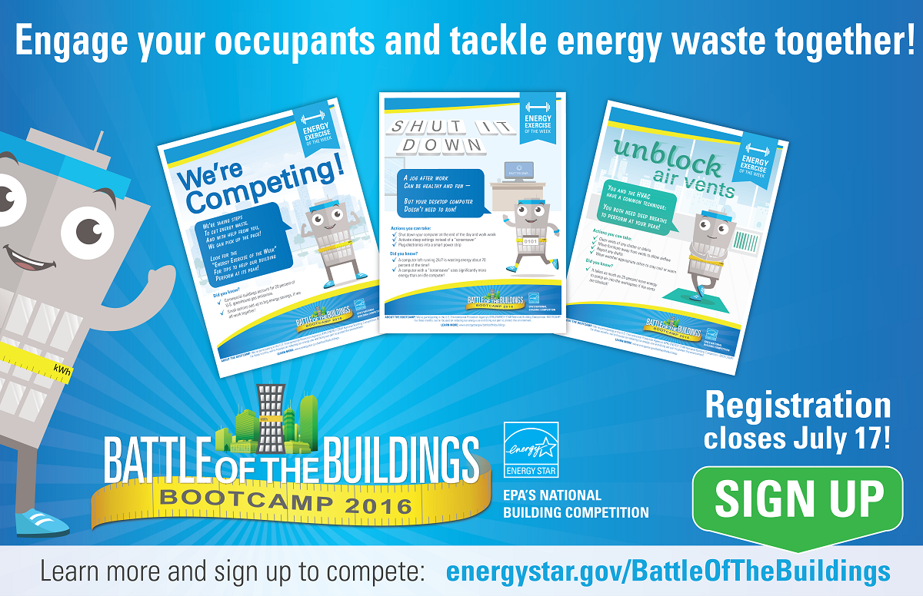
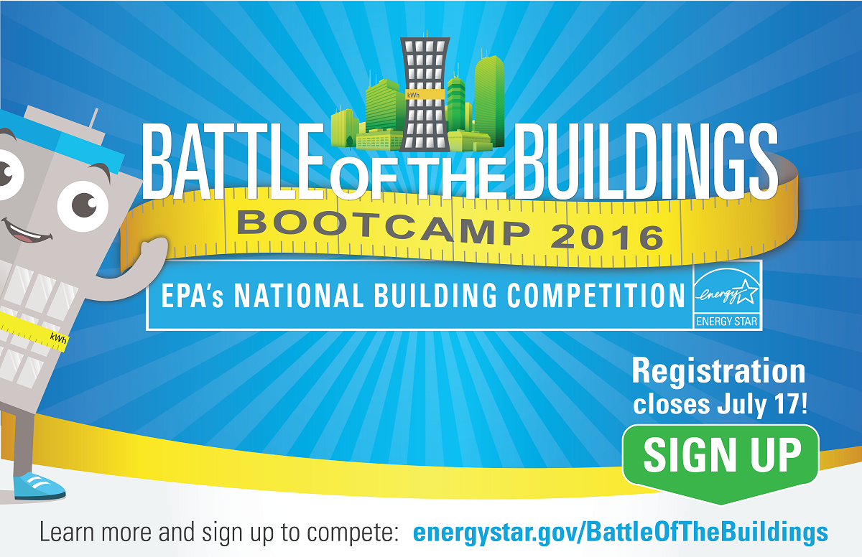

Sample Newsletter Article
EPA invites you to transform your buildings into lean, green, energy-saving machines in just 90 days this year, with the ENERGY STAR® National Building Competition: BOOTCAMP!
Join the fun and team up with ENERGY STAR to engage your building occupants and employees, and build a workplace culture of energy conservation. Enroll up to five buildings today to:
- Cut out energy waste and save money on your utility bills.
- Earn EPA recognition for your environmental leadership.
- Engage your employees and boost workplace pride.
- Deliver value to tenants in the form of a more efficient workplace.
- Achieve lasting benefits for your bottom line in just three months.
- Use EPA-provided resources to save time and effort!

EPA will provide competitors with themed BOOTCAMP training kits, chock full of printable posters, social media posts, energy-saving reminders, door signs, and more. Each training kit focuses on a new energy or water-saving action in the workplace. Use the kits to engage your employees, students, and other occupants in tackling energy waste together.
Track your energy and water performance each month in EPA’s ENERGY STAR Portfolio Manager® tool, and report your savings at the end of the competition period. Within each building type category, the building with the greatest verified weather normalized energy savings (on a percentage basis) will take home top honors!
Sign up! Visit www.energystar.gov/BattleOfTheBuildings through July 17 and use Portfolio Manager to submit your building data. Enroll up to five of your buildings with the most room for improvement!

Sample “Tweets” to Post on Twitter
Are you ready for EPA’s ENERGY STAR BOOTCAMP? Enroll up to 5 bldgs by July 17! #ESNBC www.energystar.gov/battleofthebuildings
Tackle energy waste with EPA’s ENERGY STAR NationalBuildingCompetition: BOOTCAMP! Enroll by 7/17 #ESNBC energystar.gov/battleofthebuildings
Registration ends July 17 for EPA’s ENERGY STAR BOOTCAMP! See you out on the field! #ESNBC www.energystar.gov/battleofthebuildings
Get your energy and water data ready for the 2016 BOOTCAMP #ESNBC, and register to compete at www.energystar.gov/battleofthebuildings
July 17 is the last day to enroll 5 bldgs for EPA's ENERGY STAR BOOTCAMP! See you out on the field! www.energystar.gov/battleofthebuildings

Sample Web Text
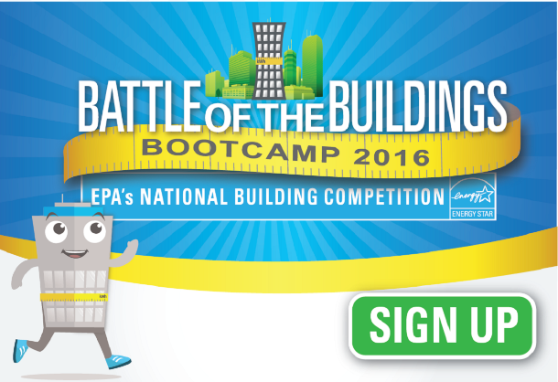
(For added visual interest, pair the following text with a web banner or button and hyperlink the image to www.energystar.gov/BattleOfTheBuildings)
Register by July 17 for EPA’s 2016 ENERGY STAR® National Building Competition: BOOTCAMP!
Are you looking for ways to save energy, reduce operating costs, engage your building occupants and tenants, and get some positive publicity for your environmental leadership? Join the U.S Environmental Protection Agency’s 2016 ENERGY STAR National Building Competition: BOOTCAMP! Register today and get ready transform your buildings into lean, green, energy-saving machines in just 90 days.
How does it work? EPA will provide competitors with themed BOOTCAMP training kits, chock full of printable posters, social media posts, energy-saving reminders, door signs, and more. Each kit will focus on a new energy-or water-saving action in the workplace. Use the kits to engage your employees, students, and other occupants in tackling energy waste together, one new action at a time.
How are results measured? Track your energy and water performance each month in EPA’s ENERGY STAR Portfolio Manager® tool, and report your savings at the end of the competition period.
How can I win? Within each building type category, the building with the greatest verified weather normalized energy savings (on a percentage basis) will take home top honors!
Sign me up! Registration ends July 17. Visit www.energystar.gov/BattleOfTheBuildings to enroll up to five of your buildings, and use Portfolio Manager to submit your building data. Then get ready for the competition launch on September 1!

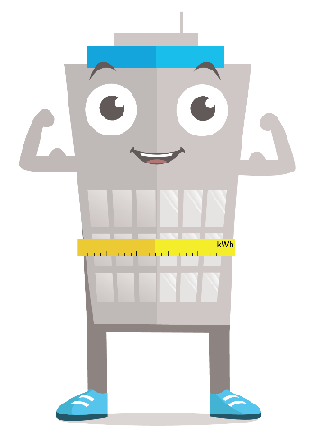
Register today for the ENERGY STAR Battle of the Buildings: BOOTCAMP!
Lace up your shoes and get out on the field! The U.S. Environmental Protection Agency (EPA) has opened registration for its 2016 ENERGY STAR® National Building Competition: BOOTCAMP! Register today and get ready to transform your buildings into lean, green, energy-saving machines in just 90 days.
Join the fun and team up with ENERGY STAR to engage your occupants and employees, and build a workplace culture of energy conservation. No matter how efficiently your building is designed, your occupants are critical to saving energy. It’s a win for your bottom line and a win for the planet! Enroll your buildings today and get ready to:
- Cut out energy waste and save money on your utility bills.
- Earn EPA recognition for your environmental leadership.
- Engage your employees and boost workplace pride.
- Deliver value to tenants in the form of a more efficient workplace.
- Achieve lasting benefits for your bottom line in just three months.
- Use EPA-provided resources to save time and effort!

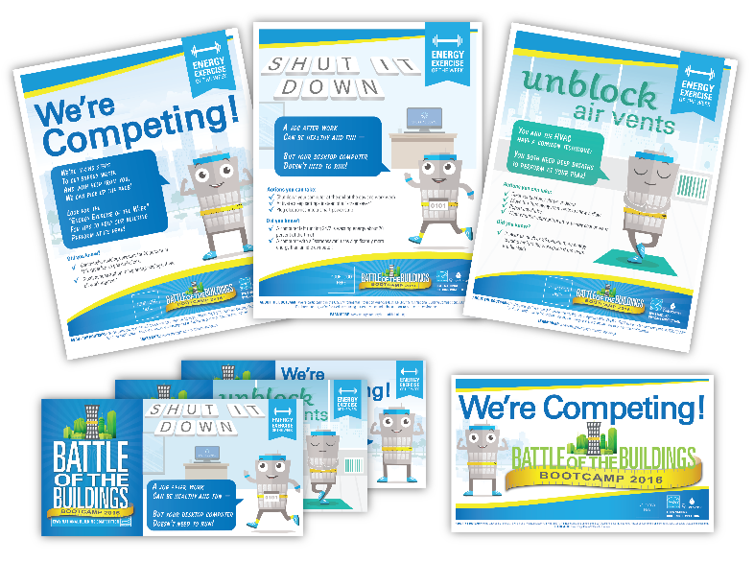
What’s involved?
EPA will provide themed BOOTCAMP training kits chock full of printable posters, social media posts, energy-saving reminders, door signs, and more. Each kit will focus on a new energy- or water-saving action in the workplace. Use the kits to engage your employees, students, and other occupants in tackling energy waste together, one action at a time!
Track your energy and water performance each month in EPA’s ENERGY STAR Portfolio Manager® tool, and report your savings at the end of the competition period. Within each building type category, the building with the greatest verified weather normalized energy savings (on a percentage basis) will take home top honors!

Sign me up!
Registration ends July 17. Visit www.energystar.gov/BattleOfTheBuildings to enroll up to five of your buildings, and use Portfolio Manager to submit your building data. Then get ready for the competition launch on September 1!
See you out on the field!

